



**AUTHORSHIP**

*During the project, I have read many different materials from both Vietnamese and foreign textbooks, monographs to articles. I guarantee that what I have written below is completely authentic, true, the experimental measurements obtained in the thesis are not copied from any document in any way. Those results are what I have researched, accumulated in the process of making this thesis.*

*I take full responsibility for any sign of copying results from other documentation.*

*Hanoi, May 10th 2021*

Student

Hoang Vu Long

**ACKNOWLEDGEMENTS**

*First of all, I would like to express my gratitude to Dr. Lam Sinh Cong, who enthusiastically instructed and guided me throughout the graduation thesis process.*

*I sincerely thank all teachers who created favorable conditions for me to study and research at the University of Engineering and Technology - Vietnam National University, which has helped me a lot in supporting the professional knowledge as well as the facilities to complete the thesis.*

*Finally, I would like to thank my family and friends who are always by my side and encourage me throughout the process.*

*In the process of making this thesis, due to limitations in knowledge, unavoidable shortcomings, I look forward to receiving comments from teachers and friends to complete this thesis.*

*Sincerely thanks!*

*Hanoi, May 10th 2021*

Student

Hoang Vu Long

**TABLE OF CONTENTS**

LIST OF FIGURES 5

LIST OF TABLES 6

LIST OF ACRONYMS 6

ABSTRACT 8

**CHAPTER 1.** OVERVIEW OF 5G MOBLIE NETWORK 9

1.1. Introduction of 5G mobile network 9

1.2. 5G network architecture 10

1.3. New approaches and technical requirements 14

1.3.1. New approaches for future IMT 14

1.3.2. Technical requirements 15

1.4. New insights in 5G Development 16

1.4.1. Extremely short Wave (mmWave) 16

1.4.2. Massive MIMO and Beamforming 17

**CHAPTER 2.** 5G ULTRA-DENSE NETWORK AND

POWER OPTIMIZATION 20

1. 2.1. Overview of 5G UDN 20
2. 2.2. The operating principle of 5G UDN System model 21
3. 2.3. The risk of interference in 5G UDN 23
4. 2.4.Spectral efficiency & Energy efficiency and
5. Power optimization problem 23
6. 2.4.1. The definition of Energy efficiency & Spectral efficiency 23
7. 2.4.2. EE & SE optimization problem 25

**CHAPTER 3.** METHODS FOR POWER OPTIMIZATION 27

3.1. Fundamentals of Reinforcement Learning (RL) and Q-Learning 27

3.1.1. Overview of RL 27

3.1.2. Overview of Q-Learning 29

3.2. Deep Q Network (DQN) 30

3.3. Dueling DQN 32

**CHAPTER 4.** SIMULATION AND RESULTS 35

4.1. Constructing the program of simulation 35

4.1.1. The hypothesis of power optimization 35

4.1.2. Python libraries for Data Science used in simulation 36

4.1.3. Simulation Parameters 38

4.2.Simulation Results 40

CONCLUSION AND FUTURE ORIENTATION 43

APPENDIX 44

REFERENCES 45

**LIST OF FIGURES**

**CHAPTER 1**

Figure 1.1. 5G Architecture based on area distribution and

connection types [6] 10

Figure 1.2. 5G Architecture based on network slicing [12] 12

Figure 1.3. 5G Core network [13] 13

Figure 1.3. Three approaches for future IMT [14] 14

Figure 1.4. Length of spectrums for 5G [15] 16

Figure 1.5. Massive MIMO Model with 3D Beamforming [16] 19

**CHAPTER 2**

Figure 2.1. 5G UDN Model [21] 21

**CHAPTER 3**

Figure 3.1. Reinforcement learning model [25] 28

Figure 3.2. Simple view of artificial networks [35] 31

Figure 3.3. Deep Q Learning model [9] 31

Figure 3.4. The model of Dueling DQN [28] 33

**CHAPTER 4**

Figure 4.1. Network model in simulation 36

Figure 4.2. Minimum total power consumption when time varies at 10 Mbps 40

Figure 4.3. Average total power consumption when UE demand changes 41

**LIST OF TABLES**

Table 1. The comparison of 5G UDN and 5G traditional network 20

Table 2. Simulation parameters 38

Table 3. Simulation results 42

**LIST OF ACRONYMS**

|  |  |
| --- | --- |
| NR | New Radio |
| UDN | Ultra-dense Network |
| EE | Energy Efficiency |
| SE | Spectral Efficiency |
| IoT | Internet of Things |
| LTE | Long-term Evolution |
| EPC | Evolved Packet Core |
| ML | Machine Learning |
| RL | Reinforcement Learning |
| DQN | Deep Q Network |
| UE | User Equipment |
| EMBB | Enhanced Mobile Broadband |
| MMC | Massive Machine Communication |
| V2V | Vehicles-to-vehicles |
| URC | Ultra–reliable Communication |
| IMT | International Mobile Telecommunications |
| MIMO | Multiple Input multiple output |
| CN | Core Network |
| RAN | Radio Access Network |
| BS | Base Station |
| QoS | Quality of Service |
| gNB | Next-gen NodeB |
| MgNB | Macro gNB |
| SgNB | Small gNB |
| RB | Resource Block |
| SUE | Small UE |
| NN | Neural Network |
| API | Application Programming Interface |
| SINR | Signal to interfere-plus-noise ratio |
| AI | Artificial Intelligence |
| 3GPP | 3rdGeneration Partnership Project |
| UP | User Plane |
| CP | Control Plane |
| UDM | Unified Data Management |
| AMF | Access and Mobility Function |
| SMF | Session Management Function |
| SDSF | Structured Data Storage Network Function |
| UDSF | Unstructured Data Storage Network Function |
| PCF | Policy Control Function |
| AUSF | Authentication Server Function |
| NEF | Network Exposure Function |
| NRF | Network Repository Function |
| NSSF | Network Slicing Selector Function |
| UDF | User Plane Function |
| TTI | Threat to Interference |

**ABSTRACT**

***Abstract****:* Currently, the rapid development of Internet of Things (IoT) devices has driven a sharp increase in the density of UEs in the wireless networks, particularly 5G cellular system [1]. Thus, 5G ultra-dense network (UDN) is being introduced as a potential network topology of the 5G network [14]. In this thesis, we study the power allocation method in 5G UDN which considered two indicators, called energy efficiency (EE) and spectral efficiency (SE). In a network environment, EE and SE are always inversely proportional to the other, consequently. Hence, the problem of power optimization has to deal with the balance between the maximization of EE and SE [20]. At the moment, some Deep Learning methods and algorithms have been introduced and used as traditional Q-Learning, its modified version such as Deep Q Network and dueling DQN have been introduced to optimize power consumption and spectral efficiency. There are 4 chapters in this thesis. Chapter 1 will introduce an overview of the 5G network, its architecture and technical requirements, as well as the innovation compared with the previous generation. Chapter 2 aims to provide a brief overview of 5G UDN, EE and SE, and power optimization problems. The applications of Data Science, particularly deep learning algorithms are introduced to be methods to solve this issue and improve the system performance. In chapter 4, the problem of power optimization is considered to satisfy the increase in users demand and also guarantee the QoS in a long period of time. In this simulation, the DQN method is utilized for calculating and collecting data. Simulation results will show the optimal value of energy consumption for different access speeds required from UEs.

***Index: UDN, EE, SE, Deep RL, DQN, QoS.***

**Chapter 1. OVERVIEW OF 5G MOBILE NETWORK**

Chapter 1 provides an overview of 5G mobile networks. We start with a description of the architecture of 5G networks and consider the technical requirements and methods of approach. In addition, chapter 1 discusses several problems and solutions in designing, operating, and maintaining these networks. Then, we go into detail with the typical new technologies used for data transmission in 5G.

* 1. **Introduction of 5G mobile network**

5G is the 5th generation mobile network. This is the new global wireless network model after 1G, 2G, 3G, and 4G networks. 5G is designed to connect everyone and everything, including machines, objects, and equipment [1].

5G is a research project for the next communication generation based on the current communication technology 4G. 5G is being deployed in some countries. However, not all 5G standards have been released yet [1].

Thanks to the higher speed and data density, 5G offers many businesses and opportunities to grow. As currently deployed system 4G, we have seen that companies take advantage of this by developing motorbike, taxi services, tech-taxis, food delivery, etc. 5G is 10 times faster than 4G and much more capacity - this means a lot of new businesses could emerge. The IoT (Internet of Things) is also a feature that seems particularly relevant to 5G technology [1]. Currently, IoT is being popularly used in the manufacturing sector to track factories, as well as in the transportation sector to track vehicles. mmWave and Beamforming are introduced to be new technologies to deploy 5G cellular networks. This innovation is especially suitable for UDN in narrow coverage with high spectral efficiency. The concept of isotropic communication is investigated due to the limitation on the coverage of the beams carrying information. Therefore, network broadcasts should be transmitted continuously for all the beams [1].

5G has the potential to be faster than any Wifi network, and it can operate at any position where the signal is available. That means the IoT equipment can operate anywhere without being limited to local wireless networks. Today, the rise of connected objects and devices will create the way for a host of new services and related business models that enable automation in different industries such as quality, e-health, smart city, connected car, industrial manufacturing, etc. [1]

In addition, 5G also supports other high data rate requirements such as virtual and augmented reality, 4K video transmission, etc. In other words, it can be said that 5G networks will support our communication needs to make our lives more affordable, safer, and more convenient.

**1.2. 5G Network architecture**

All changes made by the mobile generations have been based on a new radio link concept and have provided an increase in data rates. The minimization of latency is the main requirement of the 5G network system. Integration of new services and application areas such as IoT, Vehicle-to-Vehicle communications, …. is also important. In addition, 5G must cater to the requirements of different machine-style communications [1]. For example, the data rates will vary from very low for the sensor to very high for high-quality video.

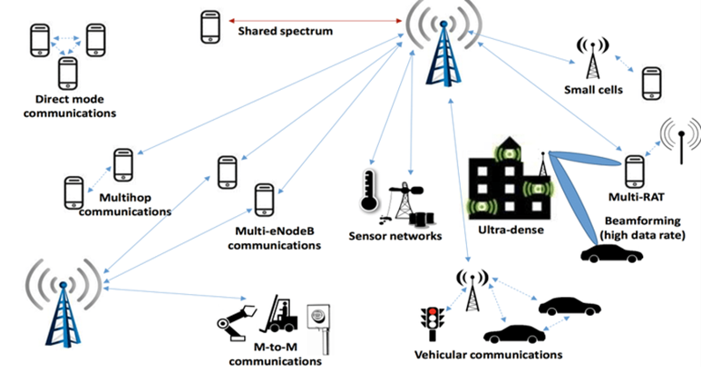

***Figure 1.1. 5G Architecture based on area distribution and connection types* [6]**

The fluctuation of system latency depends on the package size of the application. 5G is expected to be a radio multi-access technology system that integrates effectively the following basic building blocks:

* Enhanced Mobile Broadband (EMBB) will provide higher data rates and lower latency communication that improve the quality of service (QoS) for users [1].
* Massive Machine Communications (MMC) will provide connectivity solutions, support expansion for a huge number of network devices, which can improve the connection for mobile and wireless communication systems in the future [1].
* Vehicles-to-vehicles (V2V) equipment, infrastructure, and driver assistance services require the interaction of vehicles with each other and their environment to improve traffic safety and future traffic efficiency [1]. V2V services for cellular networks demand highly reliable communication links and allow the transmission of data packets with maximum latency even when the vehicle is at high speed.
* Ultra–reliable Communication (URC) will provide scalable and cost-effective solutions for networks with high requirements of reliability and availability. When the number of users increases, by utilizing a supportive system architecture, the highly reliable service reduces speed and increases latency mechanisms to deploy media [1].
* MBB, voice service, and SMS. Because of the increase in the number of customer requests, mobile network management will significantly improve automation for management to boost the entire operation of the network cells [1].

The existence of automated communication device applications will generate traffic to the mobile network and support 5G networks performance metrics (KPIs).

Therefore, the division of network layers will meet the needs of industries, which require separate telecommunications services, by dividing them into slices by modeled operators, called Network slicing. The network system is divided into 3 layers: Service layer, Network layer, and Resource & Functional layer [1]. Each layer is divided into separate slices shown in Figure 1.2:

* Service Layer: Automation & V2X, IoT
* Network Layer: Network Operating System
* Resource & Functional Layer: Wide area network, wireless network, core network on Cloud

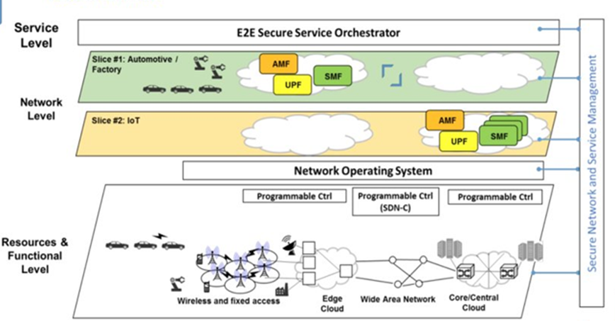

***Figure 1.2. 5G Overall Architecture based on network slicing*. [12]**

Technically, there are 2 main components in 5G wireless networks, namely Radio Access Network (RAN) and Core Network (CN). In terms of RAN, this component is mainly composed of 5G. 5G small cells are in large clusters because the mmWave spectrum can only travel over short distances. These small cells complement the macro cells to provide wider coverage. Macro cells utilize MIMO (Multiple-Input-Multiple-Output) antennas with multiple connections to send and receive large amounts of data. This means that multiple users can connect to the network at the same time.

5G Core Network, adopts a service-based architecture with a set of functional blocks. This set of functional blocks is divided into three groups [13]. The first group runs in the Control Plane (CP) and has some components that play a similar role as in the Evolved Packet Core (EPC) in 4G LTE [13].

* UDM (Unified Data Management): Manages user identity, including the authentication of UEs
* SMF (Session Management Function): Manages each UE session, including IP address allocation, control aspects of QoS, and control aspects of routing
* AUSF (Authentication Server Function): Manages an authentication server.
* PCF (Policy Control Function): Manages the policy rules to control functions.
* AMF (Core Access and Mobility Management Function): allows connection and manages mobility, access authentication, and authorization.

The second group also runs in the CP but does not have a direct counterpart in the EPC:

* NSSF (Network Slicing Selector Function): select a Network Slice to serve UEs. Network Slices are essential parts of allocating network resources to different users.
* SDSF (Structured Data Storage Network Function): A network function used to store structured data.
* NEF (Network Exposure Function): exposes capabilities to translate between internal and external data representation.
* UDSF (Unstructured Data Storage Network Function): A network function used to store unstructured data.
* NRF (NF Repository Function): discovers available services.

The third group includes the one component that runs in the User Plane (UP):

* UPF (User Plane Function): Forwards traffic between RAN and the Internet. In addition, it takes responsibility to enforce QoS policy.

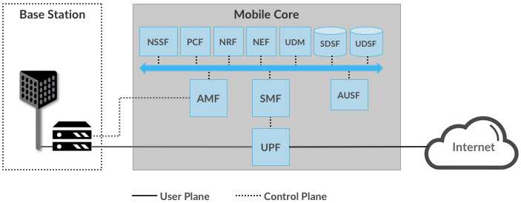

***Figure 1.3. 5G Core Network.* [13]**

**1.3, New approaches and technical requirements**

Currently, there is a trend that 5G networks aim to connect almost anything, gradually satisfy human needs for new layers of service and higher levels of reliability and latency. Developing and exploiting 5G networks requires not only brighter ways of logical thinking but also advanced network knowledge. The demand for existing and new services differs in many respects. As a result, we cannot have high reliability at a low cost, so 5G needs to be scaled to the level of performance suitable for one service while reducing costs for another [1].

**1.3.1, New approaches for future IMT**

ITU-Radiocommunication, one of three units of the International Telecommunication Union (ITU) has summarized three approaches for future International Mobile Telecommunications (IMT), showing the difference between the properties of development aspects in 5G in Figure 1.3 [2].

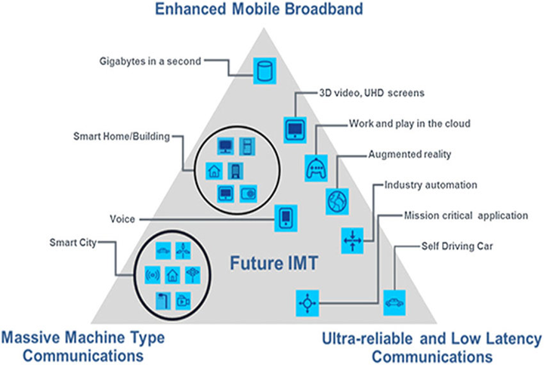

***Figure 1.4. Three approaches for future IMT.* [14]**

* EMBB: allows access to multimedia content, services or data. Enhanced mobile broadband demand will continue to increase, results in the growth of mobile broadband. The modified version of mobile broadband improves user performance and experience for new fields of application beyond the capabilities of existing mobile broadband applications [2].
* Ultra-reliable and Low Latency Communications: This connection has requests for network and device capabilities such as throughput, latency, and availability [2]. Some examples include industrial manufactory or medical surgery, intelligent grid distribution automation, traffic safety, etc.
* Massive machine-type communications: This connection is used data transmissions are not sensitive to delay. Devices are proposed to supply a low-cost and long-term service [2].

**1.3.2, Technical Requirements**

Several requirements are indicated if the current network is utilized to handle the explosive growth of the mobile Internet and IoT:

* Energy efficiency, the total cost per bit, and complexity of network deployment & maintenance cannot handle traffic growth [2].
* Existing networks must monitor network resources accurately and perception of services effectively [2].
* Control the complexity when many access technology devices significantly affect the QoS [2].
* The widely distributed frequency spectrum will cause interference and complexity, so it must be handled with measures [2].

To do this, 5G requires the following capabilities to achieve sustainability:

*A, In terms of network construction and deployment, 5G networks need to:*

* Provide more capacity and better coverage and reduce network deployment complexity and costs [2].
* Build a flexible and scalable structure to fulfill the needs of users and services [2].
* Be flexible and efficient to various spectrum resources, including both low-frequency and high-frequency range [2].
* Connect more powerful devices to handle the access requests of a large number of IoT devices [2].

*B, In terms of operations and maintenance, 5G networks need to:*

* Improve energy efficiency and cost per bit to deal with the rapid growth of data traffic and diversified needs of services [2].
* Reduce complexity due to the coexistence of multiple radio access technology, and introduce new features and functions to improve the user experience [2].
* Offer a wide range of security solutions to meet the needs of all types of devices and services of the mobile Internet and IoT [2].
* Interference, energy consumption, and cost are the three primary factors that must be addressed in sustainable mobile communications networks. To achieve sustainability, 5G needs to significantly improve spectral efficiency, energy efficiency, cost performance [2].

**1.4, New insights in 5G Development**

**1.4.1, Extremely short Wave (mmWave)**

Demand for access to more spectrum is accelerating for eMBB mobile services continues to grow globally. Frequency is a decisive factor for a cellular connection as well as access to a broader spectrum. Then, the network will perform better, which means faster data processing speed and enhanced user experience. 5G networks will use new higher bands than previous mobile communications networks. The frequency band of 5G is divided into Low band, Mid band, and High band (mmWave) [3] with:

* Low band: from 1 GHz to 6 GHz
* Mid band: from 6 GHz to 24 GHz
* High band: above 24 GHz

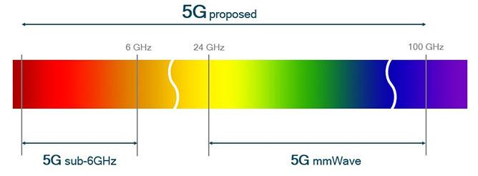

***Figure 1.5. Length of spectrums for 5G*. [15]**

Up to now, high bands above 24 GHz have been used for a long time in well-designed communications for wireless and satellite infrastructure networks [3]. However, mobile networks are only deployed in frequencies below 3 GHz because, at extremely high frequencies, especially mmWave bands, the mobile broadband application will be ineffective due to the narrow transmission range [3].

With mmWave, multiple small-sized antenna elements are used with small wavelengths at high frequencies. This feature of mmWave will be applied in a 5G system when large MIMO antenna arrays are used to create ultra-dense beams, capable of transmitting waves with higher energy to handle congestion and loss on both uplink and downlink [3]. These directional beams can also be reused in space.

In mmWave implementations, it is possible to capture reflected signals or non-line-of-sight signals and use them to complement line-of-sight signals to increase the channel capacity [3]. Therefore, the reflected signal can be applied to maintain the connection between mobile devices even when it moves to the edge of the small cell. This is the reason why mmWave has an important role in 5G mobile broadband development.

Rapid adaptation for changing channel conditions is essential to 5G mmWave. At mmWave frequencies, even a small variation in the environment, such as head rotation, hand movement, or a passing car, can also change the channel and impact performance [3]. In the mmWave system in 5G, redirection and switching techniques are used to quickly detect and transfer connections both inside and outside the access points.

**1.4.2, Massive MIMO and Beamforming**

MIMO stands for multiple-input-multiple-output. The MIMO technique meets the network demand when the number of antennas on the device is increased by 100 times. With MIMO, spectral efficiency is improved through multiple transmission paths between the base station and the terminals. MIMO has been adopted for both Wi-Fi and LTE networks [3]. A huge step forward was to upgrade to Massive MIMO in the TDD band because TDD does not require a paired spectrum with different frequencies when transmission and reception occurs. Massive MIMO allows us to use a large system of antennas at the same time. Massive MIMO is one of the main platforms for 5G, along with larger channel bandwidth, access to new mmWave bands and network slices. Massive MIMO is a key component to enable wider signal coverage for mmWave bands used in 5G [3]. Massive MIMO can improve both the coverage and throughput of 5G networks.

Using multiple antennas at the same time when using high frequencies such as mmWave, the emitted wave will be shaped in beamforming. Beamforming uses multiple antennas to control the direction of a wavefront by balancing the magnitude and phase of the signal on individual antennas [3]. Hence, coverage is provided for the specific areas located at the cell margins better. Every single antenna in the array contributes strength to the directional signal, resulting in the array gain (beamforming gain). Beamforming can prevent interference by applying a null beam pattern in the direction of the noisy signal [3]. Adaptive beamforming is a technique that applies continuous beamforming for a moving receiver, enables to keep the connection at even several hundred km/h. Only 5G can fulfill the requirements of a fast signal processor and powerful algorithms [3].

For beamforming-based Massive MIMO, the radio signal focus on areas with specific terminals. The spectral performance is mainly improved because beamforming in 5G is more advanced than the previous generation, resulting in improvement of signal accuracy and call quality at the cell edge [3]. Massive MIMO's difference essentially comes from the fact that the service suppliers can increase the network capacity without using additional transmitters or base stations. Below is a summary of the 2 biggest benefits that Massive MIMO brings:

- Improve spectral performance, increase network throughput, and upgrade network capacity. The system sends and receives multiple data signals on the same radio channel, increasing spectral efficiency in a small cell with a large number of UEs at the same time [3]. This increases the peak cell throughput and improves

mean efficiency.

- Beamforming makes the signal stronger, reduces noise for better coverage, and improves QoS, especially at the cell edge. Beamforming allows for extended cell range compared to traditional antennas [3]. This is especially efficient for higher frequencies, where the beam compensates for higher path losses.

5G is the largest platform that use Massive MIMO. In markets of 5G technology with huge demand for data usage and more capacity, Massive MIMO is one of the most efficient ways to do this. The main deployment areas are dense urban traffic hotspots and by applying full-dimension MIMO (Figure 1.6) where the beam is better access to users in tall buildings [3]. In addition, upgrading networks using Massive MIMO will improve mobile operators and supply a sustainable network infrastructure.

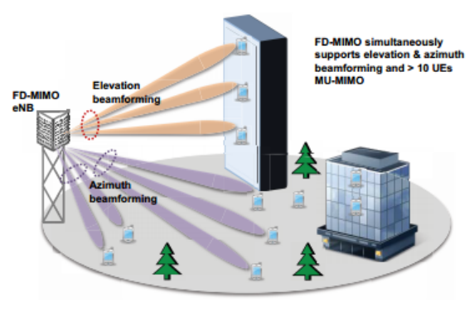

***Figure 1.6. Massive MIMO Model with 3D Beamforming*. [16]**

**Chapter 2. 5G ULTRA-DENSE NETWORK AND POWER OPTIMIZATION**

In chapter 2, a new technology will be introduced in the 5G Network to deal with the rapid growth of the UEs density, 5G Ultra-Dense Network (UDN). This chapter represents the power allocation process over 5G UDN, two categories of Spectral Efficiency (SE) & Energy Efficiency (EE) to evaluate network performance. Lastly, we discuss the optimization problem to ensure the long-term performance of the UDN system.

**2.1. Overview of 5G UDN**

The communication requirement of smart devices and environmental mass IoT drive the density as well as the performance of 5G network infrastructure. Therefore, the network needs to be very dense with many layers in the future. 5G UDN is introduced to be a potential development of 5G networks [15].

The main difference between UDN and traditional cellular networks is the base station (BS) density. In UDN, the BS's coverage radius is only about 10m, and there will be thousands of BSs per km2. But in traditional cellular networks, the cell range is more than 500 m and there are usually 3-5 BS in 1 km2 [4]. Correspondingly, terminals are connected to a gNB, while there are hundreds or even thousands of users residing and operating in a macro cell of the traditional network. The table below shows a comparison of UDN and traditional mobile networks [4].

**Table 1. The comparison of 5G UDN and 5G traditional network**

|  |  |  |
| --- | --- | --- |
| **Criteria** | **UDN** | **Traditional Mobile Network** |
| **gNB Density** | Over 1000 BS/ km2 | 3 ~5 BS/ km2 |
| **gNB Type** | Small cell | Macro cell |
| **UE Density** | Ultra-Dense | Medium |
| **Bandwidth** | > 100 MHz | < 100 MHz |
| **Spectrum** | > 3 GHz up to mmWave | < 3 GHz |
| **Coverage** | Narrow area | Wide area |

In UDN architecture, the radius of the cells reduces further and causes an increase in intercellular interference. Furthermore, due to the heterogeneity of user devices over time and space, it is more difficult to manage the UDN's energy [4]. Therefore, the adaptive power allocation in the UDN is worth further discussion. The resource allocation policy in the UDN affects the network in terms of form and user testing.

In general, 5G UDN is a new wireless networking solution that supplies higher throughput and better QoS. In UDN, the gNB density can be even higher than the user density [4]. Different types of gNBs will work closely to achieve higher spectral efficiency, lower power consumption, and more seamless mobility.

**2.2, 5G UDN System model**

We consider downlink 5G UDN model shown in Fig. 2.1, where one macro cell contains *N* small cells.

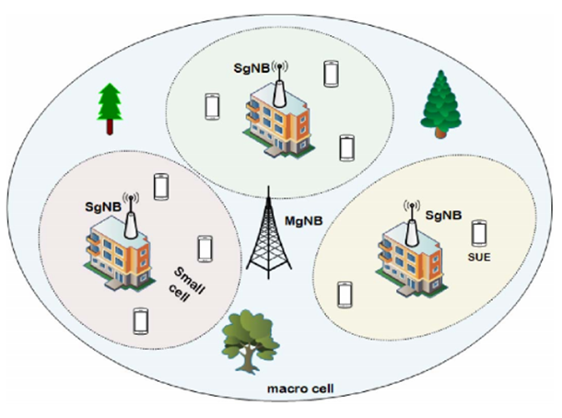

***Figure 2.1. 5G UDN Model.* [21]**

In this macro cell, there is a macro gNB (MgNB) at the centre. A small gNB (SgNB) is deployed in each small cell. The set of SgNB can be described as {1,2,., *N*}. There are M available RBs with the set of {1,2, …, *M*} and the bandwidth of each RB is *Bm* [18]. The function of MgNB is to collect information and determine available RBs. Each SgNB selects one RB from the set of RBs and assigns it to a small UE [22].

The user arrival and departure process can be described as two independent processes in every network. According to the Poisson formula, UEs arrive at each small cell with parameter *λt* in each time slot [22]. Hence, we have the probability of the arrival of *x* new UEs to small cell during the period τ:

*P(x) =* (1)

In a similar way, UEs depart from a small cell with parameter *μt*. Thus, we have the probability of the departure of *y* UEs from the small cell during the period τ:

*P(y) =* (2)

It is assumed that the completion of UEs associated with small cells occurs just before the power allocation [22]. Then, the number of UEs in a small cell in time slot *t* can be expressed as:

*Un(t)* = {1, 2, 3, *…., Sn(t)*} (3)

In this thesis, the same RB can be simultaneously reused by some SgNBs. Thus, SgNBs will interfere with each SUE of the other small cells [22]. After the allocation of the RB *m* to the *Sn(t)*, its SINR in small cell *n* can be given by:

SINR = (4)

* : channel gains between SgNB *n* and SUE *sn* while RB *m* is reused.
* Pn: power to each SUE assigned by SgNB n; σ2: Interference.
* : a binary variable representing the RB allocation indicator and it receives value ‘1’ when the RB *m* is allocated to the small cell *n*, and value ‘0’ otherwise [22].

To sum up, the downlink Sum throughput (bit/s) in the *n*-th small cell can be given by according to Shannon’s formula [22]:

Rn(t) = = (5)

In conclusion, we have the total throughput (bit/s) of the whole system:

R(t) = = (6)

**2.3, The risk of interference in 5G UDN**

The large number of BSs can bring far higher throughput and better QoS, but can also lead to interference problems. Interference management can directly affect system performance. Along with more energy consumption to serve more demand for access, interference also increases and becomes more complex than traditional mobile networks [5]. Thus, there are several problems:

- Ultra-dense radio environment with a huge number of SgNBs leads to more sources of interference. In a small cell, a lot of terminals and BSs coexist. The signal may have more reflection and dispersion paths [5]. Then the transmission power will increase in a period, it will create more interference than before.

- Current parameters to evaluate the impact of noise such as possible noise threshold does not reflect the overall performance of the network. Therefore, it is necessary to use the appropriate parameters more to give a better indication between the results of minimization of interference and throughput, efficiency energy capacity, and other system parameters [5].

- Reducing interference and increasing energy efficiency become two contradictions and we need to find the right solutions to optimize the system performance [5].

**2.4, Energy efficiency & Spectral efficiency and Power optimization problem.**

**2.4.1. The definition of Energy efficiency & Spectral efficiency**

The 5G UDN, as a key technology for future wireless networks, is being studied for the deployment of a massive number of small cells in the network. An effective approach to reducing the energy consumption of the UDN is to control the power- saving mode of BSs, while the challenge is to maintain the number of SgNBs and to minimize the occurrence of interference [17]. In this thesis, we present several constraints on network performance based on the improvement of SINR, the requirements of users, and the capacity of the network, including UE coverage, average data rate, and the total throughput of the system.

In terms of power allocation in 5G UDN, energy efficiency (EE) and spectral efficiency (SE) are considered. They are weighted due to the dynamic nature of the environment. As a result, the issue of power optimization can be described as EE and SE optimization [22].

EE is the ratio that evaluates whether the amount of energy required is power-saving or not. The improvements in EE are generally achieved by the utilization of a more efficient technology or methods to reduce energy losses. Energy efficiency is defined as the number of bits per second transmitted for every unit of energy consumed [18]. The optimization issue concentrates on calculating the minimum energy consumption to supply the users but still ensure the QoS. In this scenario, EE is the ratio between the total throughput (bit/s) and total power consumption (W) [22]. In the time plot *t*, we can calculate EE as:

(7)

where PM: power of MgNB

PC: power consumption of circuit transmissions

  A wireless communication system should effectively use the spectrum. SE describes the amount of data transmitted over a given spectrum or bandwidth with minimum transmission errors. In this scenario, SE is the ratio between the sum throughput (bit/s) and total bandwidth (Hz) of the system [23]. In time plot *t*, we can calculate SE as:

(8)

Also known as bandwidth efficiency, a cellular network's SE can maintain an acceptable QoS thanks to the improvement of SE, therefore, the occurrence of interference can be restricted [19]. The number of users accessing the network affects the SE in wireless communications. In this scenario, the data transfer rate depends on the transmission device's bandwidth and the SINR. The improvement of SINR have an important role to boost the spectral efficiency of the system [19]. According to Shannon’s formula [19], there is a relation between the SE and the SINR, therefore, the formula is expressed as:

= (9)

 To conclude, in order to increase SE for a given system, we have to improve its SINR. The SINR directly affects the reduction of interference.

**2.4.2. EE and SE Optimization Problem**

When power is allocated in each period, only newcomers receive it. If a RB has been occupied in a small area at a time, its allocation will not be considered. During the process of optimization, interference may occur, and it leads to smaller SINR. Moreover, it results in the minimization of the total throughput of the whole system. In this section, we investigate the balance between the maximization of EE and SE. Our objective is to maximize both EE and SE of the network to satisfy the speed requirements of users and minimize signal interference [20]. Thus, it is considered to be a multi-objective optimization problem.

To guarantee the long-term performance of EE and SE in the UDN system, the optimization problem is that EE is inversely proportional to SE [23]. When SE is maximized and it contributes to boost the power used in the system. Meanwhile, it causes the reduction of EE. In contrast, maximizing EE may decrease SE. When UE demand rises, it causes an increase in the total amount of power generated by SgNB, MgNB, and circuit transmissions. which leads to the rise of interference [23]. During peak hours, increasing SE is more important than the EE to satisfy the demand of the network. On the other hand, during the off-peak hours, maximizing EE becomes more important to save energy. Due to the increase in the number of UEs, the role of SE grows while EE becomes less significant. Because of the mentioned reasons, it is unable to meet the requirements only by optimizing SE or EE.

The questions are raised about the tradeoff between EE and SE. According to access requests from UE, dynamic weights are given for EE and SE as the optimal power of the system is determined by the satisfaction of QoS [20]. The weighted sum method has been used to combine the EE and SE metrics [23]. Hence, we have the expression of the weight between SE and EE in the time plot *t*:

(10)

Briefly, the solution focuses on the tradeoff between SE and EE [23]. The tradeoff between SE and EE can be calculated as:

= (11)

satisfy 4 conditions:

(t) ≥ R0, ∀t ∈ T, ∀n ∈ {1,..,N}, ∀sn ∈ *Un* (11a)

∈ {0,1}, ∀t ∈ T, ∀n ∈ {1,..,N}, ∀m ∈ {1,…,M} (11b)

= Sn(t), ∀t ∈ T, ∀n ∈ {1,..,N}, ∀m ∈ {1,..M} (11c) < *Smax*, ∀t ∈ T, ∀n ∈ {1,..,N}, ∀sn ∈ Un (11d)

Condition (11a): ensure QoS of SUE by requesting higher than expected throughput thresholds.

Condition (11b): at time plot *t*, the small cell has two options (‘1’ means Yes và ‘0’ means No) and it can only choose one to reuse RB *m*.

Condition (11c): it can assign each RB to a maximum of one UE in each small cell.

Condition (11d): a small cell can only serve a maximum number of UE Smax so only a finite quantity of UE can be held in each small cell.

**Chapter 3. METHODS FOR POWER OPTIMIZATION PROBLEM**

In this chapter, we will discuss some Data science-based methods to solve the power allocation problem. Reinforcement Learning (RL) is introduced as a basic algorithm (Q-Learning) to solve this problem. Then, deep learning is adopted to improve the system performance and we propose new algorithms that can be defined as Deep Q Network (DQN) and its upgraded version, Dueling DQN.

**3.1, Fundamentals of Reinforcement Learning (RL) and Q-Learning**

**3.1.1, Overview of RL**

To solve the problem of optimizing power consumption, the deep Reinforcement Learning (RL) method is applied. RL is a field of Machine Learning, consisting of 7 main elements: ***Agent, Environment, State, Action, Reward, Episode, Policy*** [8]***.***

RL plays a crucial role in finding a method to select the actions of an agent in the environment and then, maximize a long-term reward. RL algorithms will find a strategy to map states of the environment to actions chosen by the agent [8]. RL is a trial-and-error method, this means trying again and again and learning from each other [8]. To clarify it, we have a specific process:

* Agent takes actions while the environment is the world in which the agent exists and operates [7].
* Agent choose the action for the environment based on current state st
* The environmental state changes after the action at has been accepted in the observations step [7].
* The agent continues to choose the next action based on the reward and the current state of the environment is st+1 at time *t+1* [7].
* At the same time, a reward feedback rt is sent to Agent.
* The selection principle is to increase the reward probability to get the optimal strategy and finally, we can calculate total reward throughout the process

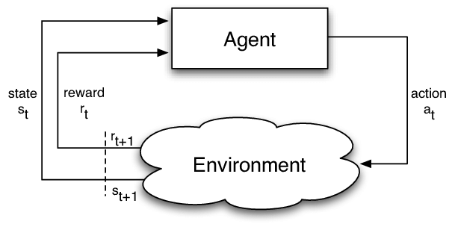

***Figure 3.1. Reinforcement learning model.* [25]**

As it can be seen, environment, state, and reward are the three key factors in RL. In this study, we define the state space, action space, and the reward function in time slot *t* based on the framework of RL [23].

* ***State space***: agent MgNB creates the decisions. The agent should learn the state of each small cell to establish the action [23]. So, we have the state of the agent in time slot *t*:

*st = {s1(t), R1(t), …, sn(t), Rn(t), x(t)}* (12)

It is concluded that the agent will obtain the information of number and throughput of all small cells in the system [23].

* ***Action space***: The decisions are made by the agent that small cells reuse RBs and we have a set of actions:

*at = {x1(t), x2(t), …, xn(t)}*  (13)

Due to the growth of SgNB, action space increases considerably. It is a problematic issue when action space explodes [23]. The number of state spaces becomes immense because of action’s effects on a state.

* ***Reward Function***: agent MgNB will receive instant reward rt by observing state st [19]. As our goal is to optimize , reward function η (t) at time t can be calculated as:

rt = ɳ(t) = (1 - ) + (14)

Due to the huge number of RBs and the rapid increase in the number of cells, the explosion of space occurs. We have to implement a pre-screening step before learning and it results in the limitation of the size of action space [23]. For some times t, the action can only be executed if throughput Rn(t) of the corresponding action satisfy condition (11a). The outcome of this method is the reduction of the possible value of *xn(t)* to control the MgNB’s action space [23].

**3.1.2, Overview of Q-Learning**

RL algorithm can learn the value of an action in a particular state. It does not require modeling of the environment and can handle problems with random conversions and rewards without modifications [8].

Q-Learning can learn the value function of action Q (s, a), assess the efficiency level to act in a specific state. We'll assign a scalar value based on the reward of taking an action. Q is called the value function of the action [9].

*Q(st,at) = r(st,at) + maxQ(st’,at)* (15)

* *Q(st,at)*: Q target
* *r(st,at)*: Reward of action at that state
* *maxQ(st’,at)*: Discounted maximum Q value of all possible action from the next state

At each time t, action *at = π(st)* is determined through π policy at current state *st* by agent MgNB. Allocating the available RBs will reward MgNB to SgNB [19]. In RL, the expression of expected return of the state-action value function *Qπ(st,at)* can be define as:

*(st,at)* = [ ] (16)

where γ is the discount factor.

On purpose of making future returns less relevant to the present, sum of [] converges [23]. The objective is to find an optimal strategy which receives the most rewards. For all actions selected by strategy *π∗(st) = argmax Q (st+1, at+1),* the value function *Qπ(st, at)* will be optimized by *at = π∗(st)* and it has to satisfy *Qπ(st, a­t) < Qπ∗(st, at)* [23]*.*

Q-learning is a popular method to optimize power and according to Behrman’s equations [23], *Q (st, at)* can be defined as:

*Q(st,at) = (1-α)Q(st,at) + α* [*ɳ(t)* + ] (17)

when *rt*is the reward received; state *st*transform to *st+1;* α is learning rate (0 < α <1)

* *Q(st,at)*: current value weighted by the learning rate. The closer to 1 α is, the faster Q-Value will change.
* *ɳ(t)*: achieved reward if action at is taken in state *st* (weighted by learning rate)
* : maximum reward can be obtained from state *st+1*(weighted by learning rate and discount factor)

**3.2, Deep Q Network (DQN)**

A new, powerful algorithm, Deep Q Network (DQN) is introduced as we take state as input, the output is an action [9]. DQN is a new deep RL strategy based on Deep Learning, combining the process of RL and a type of Neural Network (NN).

A **neural network** (NN) is a circuit of artificial neurons, modeled after the human brain. As neural network links to biological neurons, it is designed to recognize patterns for solving artificial intelligence (AI) issues [34]. NN is a set of deep learning algorithms and it takes responsibility for interpreting data and labeling raw inputs. All inputs such as images, sound, text must be modified into the numerical type and comprehended in vectors [34].

Neural networks have a significant part in predictive modeling, adaptive control and applications. On top of data storage, they are considered to be a clustering and classification layer [35]. These artificial networks can collect unlabeled data and once they receive a dataset of information to train on, they proceed to classify this labeled data. Thus, deep NN provides a larger range of ML applications, particularly algorithms for reinforcement learning [34].

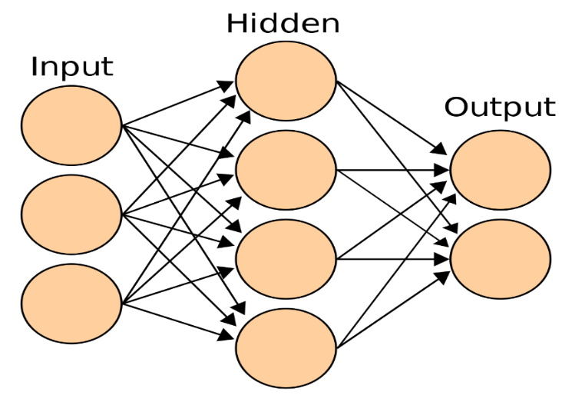

***Figure 3.2. Simple view of artificial neural network.* [35]**

From Figure 3.3, there are 3 layers in the neural network model. The first layer is the input layer, middle layers are called the hidden layer while the last layer is the output layer. The circles are nodes of the network. There are always 1 input layer, 1 output layer and the availability of the hidden layer is optional. Each node in the hidden and output layer takes responsibility to connect all the nodes from previous layers [11].

A deep NN can compute the approximation of the Q value function instead of recording and storing the solutions [9]. DNN can be used to match the optimal strategy and the optimal value function:

*Q*(st,at,θ) Q(st,at)*  (18)

where θ is the parameter of neural network [23].

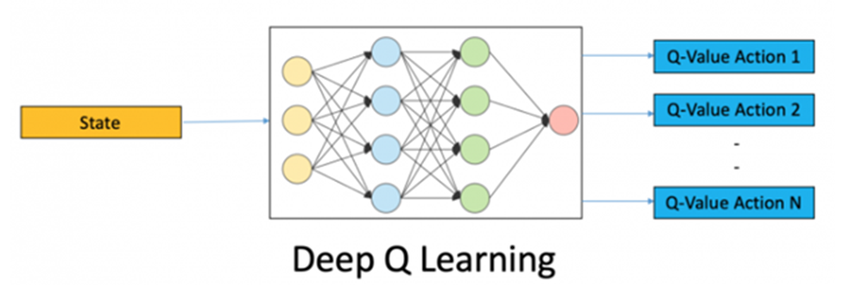

***Figure 3.3. Deep Q Learning model*. [9]**

To make NN learn how to estimate Q-Value for actions correctly, we have the loss function. The loss function calculates the error between the actual and predicted Q-value [9].

To guarantee the stability of *Q*(st, at; θ)*, the neural network is trained to minimize the loss function L(θ), to approach the real *Q(st,at)* [23]*.* L(θ) can be expressed as:

*L(θ)* = E [(ɳ(t) + ] (19)

with θ-: target network parameter; θ: behavior network parameter

**3.3, Dueling DQN**

Optimizing network capacity has to face the issue of state and action space explosion of traditional Q-learning and the instability of DQN. We use Dueling DQN to optimize power. The dueling DQN is an advanced algorithm developed on DQN structure to achieve better results [27]. Once there, the burst of state and action space is resolved and the stability of the system performance is guaranteed [26]. So, we can decompose Q (s, a) into the sum of:

*Q(s,a) = A(s,a) + V(s)* (20)

* ***V(s):*** The value of state
* ***A(s,a):*** The advantage of action in that state (how better it does to this action than any other possible actions in that state).
* ***Q(s,a)***: represents the value of choosing a particular action in a certain state.

To calculate Q-Value, we use a formula with the V function of state and the A advantage function of dependent action at [27]. Like the standard DQN architecture, we have composite classes to handle the frames. From there, we divide the network into two separate streams, one for estimating state values, and the other to estimate state-dependent action advantage. After two streams, the last module of the network combines advantage and state value outputs [26]. The process is illustrated in Fig 3.4.

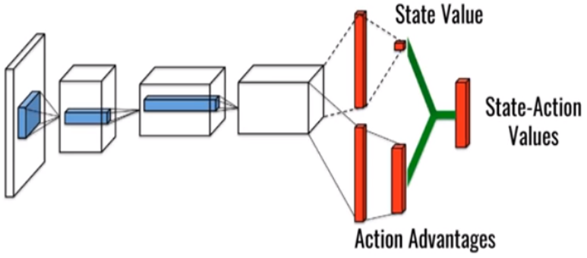

***Figure 3.4. The model of Dueling DQN.* [28]**

In some states, users receive different value function sizes of RBs and identical value functions are caused by many allocation policies. Dueling DQN is upgraded to perform the function in detail. Therefore, this model has a better performance [23]. Especially, a state-action function is separated into 2 streams with a function based on states and advantages, respectively:

*Q*(st,a­t;θ,µ,ω) = V(st;θ,µ) + A(st,at;θ,ω)*  (21)

where *μ, ω* and *θ* represents the parameters of state value streams, action advantages streams and remaining parts of model, respectively.

However, two problems with this strategy are indicated:

* It is problematic to make reasonable estimates of state values and action advantages, respectively. Therefore, intentionally adding these two values can cause problems [26].
* The simple sum of both is unknown, where for a value of Q, we cannot restore ***V*** or ***A*** solely. This lack of recognition leads to poor practical performance [26].

Therefore, the last module of the neural network performing the forward mapping is shown below:

*Q*(st,a­t;θ,µ,ω) = V(st;θ,µ) + A(st,at;θ,ω) – A(st,at‘;θ,ω)* (22)

In practice, however, the advantage stream is usually equal to the value of the advantage function of the individual actions minus the mean of all the advantage functions in a state [26]. Therefore, an alternative module will replace the max operator with the mean, the real advantage function is shown as:

*A(st,at;θ,ω) = A(st,at;θ,ω) -*  (23)

with  is average advantage value.

As a result, we have a function to calculate ***Q-Value***:

*Q*(st,a­t;θ,µ,ω) = V(st;θ,µ) + A(st,at;θ,ω) -* (24)

Not only can this operation ensure that the function of each action in this state remains unchanged, but also reduce the Q-value range and eliminate the degrees of redundancy to improve stability [23].

Because of sharing similar input-output interface as DQN, the training process of dueling is exactly the same [26]. Hence, the loss function is expressed as:

L(θ) = (25)

where *Q(st,at) = r(st,at) + maxQ(st’,at)* and performed a gradient descent step to update model parameters.

**CHAPTER 4. SIMULATION AND RESULT**

In this chapter, we will go into detail with simulation, deep reinforcement learning is used to calculate the minimum power consumption to satisfy the access speed of UE. Although there are 3 algorithms mentioned above, in this thesis, we will focus on the method of DQN. At first, we set up the hypothesis of power allocation in the optimization problem. Then, we use several Data Science libraries from Python for programming to collect data. Finally, we can calculate, analyze simulation results, to find the optimal values of power to improve the long-term performance of the system.

**4.1. Constructing the program of simulation**

**4.1.1. The hypothesis of power optimization**

To begin with, we have to raise the idea of optimizing power transmission that we set up the initial value of power generated by a SgNB in a small cell, power of a macro cell outside the small cell, and power of circuit transmissions. In that small cell, there are many UEs and they require a demand for access speed in a specific time. To satisfy the change of user demand, energy consumption needs to be adjusted. When UE requirements rise, if they have not been fulfilled yet, we have to raise the value of power up to a particular level. Then, we utilize this level of power and assess whether it meets the need of UEs or not. The increase of power consumption results in the reduction of energy efficiency of the system, therefore, to improve the EE, minimization of power consumption in a long time must be considered.

However, in a long-term process, the occurrence of interference is a complicated problem for the reason that when the total power grows, a SgNB will interfere with other BSs nearby. Due to the growth of signal interference, the SINR decreases and it results in the decline of SE. To improve the system performance when interference occurs, the number of SgNBs using the same RB at the same time should be cut down to ensure QoS. Hence, deep reinforcement learning is utilized to calculate the possibilities that two SgNBs can use the same RB at a moment. However, signals are not strong enough to meet the need for QoS.

Therefore, it is impossible to improve the system performance in a long time only considering the maximization of EE or SE. The key point of the problem is to consider the tradeoff between SE and EE for different types of UE demand (Mbps) in a small cell with a large number of users. Therefore, DQN algorithm is used to calculate the minimum total power consumption of the whole system to satisfy the UE demand and improve SINR without the reduction of the number of BSs in a specific period. To conclude, to find the optimal value of power used in the system, we take advantage of deep learning, particularly the DQN algorithm in this simulation.

Firstly, we initialize a UE demand and a time period. Then, this period of time is divided into n small intervals and we can calculate the optimal total power values for each time interval. At the next stage, the average total power used for that UE demand is calculated by the division of the sum of these values and the total number of time intervals. Lastly, we calculate the total power consumption according to the change of user demand in that interval. The total power consumption of the system is the sum of the power of SgNB Pn, the power of MgNB PM, and the power of circuit transmissions PC with n is the number of UEs in a small cell.

P = PM + +PC (26)

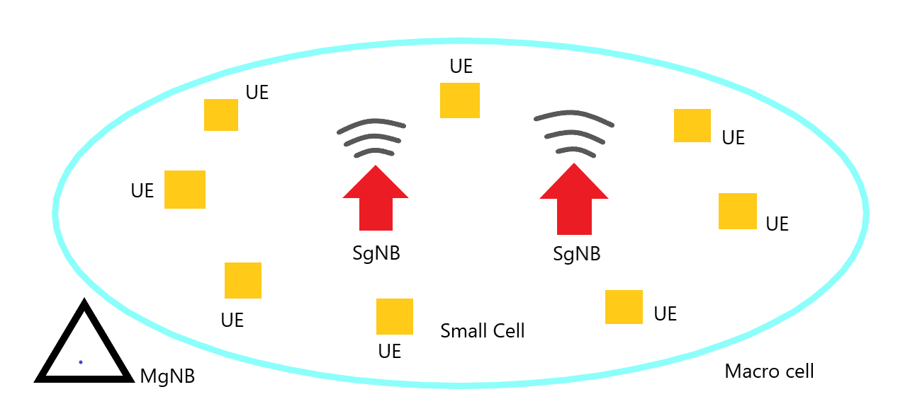

***Figure 4.1. Network Model in simulation***

**4.1.2. Python libraries for Data Science used in simulation**

Machine learning (ML) is a technology that evolved from the field of AI in Data Science. ML algorithms are computer programs that learn about how to complete tasks and how to improve performance over time. ML still requires human judgment in understanding the underlying data and choosing the right techniques to analyze the data. At the same time, before use, data must be clean, free of false positives and fake data. ML models require a sufficient amount of data to "train" and evaluate the model. In the past, ML algorithms lacked access to a large amount of essential data. Growth in big data contributes greatly to improve model and prediction accuracy [36].

Python has quickly gained popularity in the area of software development. With wealthy and powerful open-source readability and backend, developers find it easy to implement. One of the most well-known fields of Python is Data Science research. To study more about ML, it is indispensable to contribute from the generated libraries to support data analysis [10].

The wide range of use, familiarization, and understanding make it a perfect tool to handle advanced applications including complex algorithms and tools. That's why Python is an optimum method for Machine Learning and AI solutions [10]. Thus, we will take a closer look at open-source libraries of Python for data science used in this simulation program below:

* ***Numpy***: The most basic package, when the scientific computation stack is built up is NumPy (short for Numerical Python), which provides a lot of useful features for operations on n-arrays & matrics in Python. This library provides the ability to vectorize math operations in the NumPy type array, improving performance and consequently execution speed [10].
* ***Cvxopt***: is a Python-based software package for convex optimization. It is built on Python’s extensive standard library and widely used to develop software for convex optimization applications straightforward [33].
* ***Matplotlib***: A core package of SciPy Stack and another Python library built specifically for the generation of simple, powerful visualizations. You can create any visualization: Line graphs; Scatter plots; Bar charts and Histograms; Pie charts, etc. However, the library is low-level, meaning you will need to write more code to reach high levels of visualization [10].
* ***Seaborn***: mostly focused on visualization of statistical models; such visualizations include heat maps that aggregate data but still describe the overall extent of the dispersion. Seaborn is based on Matplotlib [10].
* ***Tensorflow***: is an open-source library of data-flow graphs computations suitable for Machine Learning. An important feature of TensorFlow is the multi-layer node system, allowing the training of neural networks on large datasets quickly [10].
* ***Tflearn***: is a deep learning library module built on top of Tensorflow. It is designed to supply a higher-level API to TensorFlow to facilitate and speed up tests [31]. In comparison with straight Tensorflow, the TfLearn method seems a little cleaner. One disadvantage of Tflearn is the lack of pre-trained models which are easy to integrate.
* ***Keras***: is an open-source library written in Python used to build Neural Networks at a high level of interface. This library is simple and highly extensible. Keras uses backends and has a simple design approach aimed at quick and easy experimentation from building compact systems [31]. The general idea of Keras is based on layers and everything else is built around these layers as well. Data is prepared in tensors, the first layer is responsible for the input of tensors, the last layer is responsible for the output, and the model is built in middle [10].

**4.1.3. Simulation Parameters**

**Table 2. Simulation parameters**

|  |  |
| --- | --- |
| **Parameters** | **Value** |
| System total bandwidth | 10 MHz |
| Total number of RBs | 50 RBs |
| Number of SgNBs in a small cell | 2 |
| Number of UEs in a small cell | 8 |
| Starting speed R0 of UE demand | 10 Mbps |
| Time *t* | 60 s |
| Intervals | 4 |
| Thermal noise power | -174dBm/Hz |
| Power of MgNB | 40 dBm |
| Power of SgNB | 33 dBm |
| Power of circuit transmissions | 13 W |

In this table, a resource block (RB) is the smallest resource unit allocated to a user. One RB commonly contains 12 subcarriers, each carrier wave has a frequency band of 15 kHz, therefore, the bandwidth of 10 MHz used in this simulation is divided into 50 RB or 601 carrier waves at downlink according to 3GPP standards [32]. In a small cell, the number of SgNB is 2 BSs and there are 8 UEs.

The process is simulated in a period of 60s and divides it into 4 intervals, therefore, each time interval is equal to 15s. Then, we set up values for the initial UE demand at 10 Mbps.

To calculate SINR, two essential parameters are thermal noise power and shadow fading. Thermal noise is effective and extensive white noise over a very wide spectrum. Thermal noise occurs due to the vibration of the carriers within the conductor and is proportional to the temperature, independent of the applied voltage [29]. The thermal noise power *P* is proportional to the bandwidth:

*P = k.T.B* (27)

k: Boltzmann’s constant, equivalent to 1.38 x 10-23m2kg s-2K-1

T = temperature in degrees Kelvin

B = bandwidth in Hz

This figure is then normally expressed in terms of dBm. Thermal noise in a 50 Ω system at room temperature is -174 dBm/Hz [29].

In terms of shadow fading, in wireless systems, fading can be caused by multipath propagation, known as multipath dimming, weather (especially rain) or obscuration from interfering obstacles. Shadow fading is also called slow fading because the fade time can last for seconds or minutes [30]. Moreover, the shadow fading is a large-scale discoloration and expressed with variance unit of dB. In this simulation, the shadow fading variance of SgNB is 10 dB [24].

With total bandwidth and SINR, we can have the outcome of total throughput and spectral efficiency. To evaluate energy efficiency, three different categories of power are required, namely power of MgNB PM (dBm), power of SgNB PN (dBm), and power consumption of circuit transmissions PC (W) while PM = 40 dBm, PN = 33 dBm according to [24]. The transmission power is equal to approximately 13 W.

**4.2. Simulation Results**

In this simulation, there are 2 SgNBs and 8 users in a small cell. The initial UE demand is 10 Mbps and we have four intervals for 60 s. Each time interval is equivalent to 15s. The results are shown in two graphs. Firstly, we simulate and evaluate the minimum values of power consumption in different moments and the result is illustrated in Figure 4.2. Then, we calculate the value of average power consumption when UE demand is equal to 10 Mbps.In Figure 4.3, we show the minimum average power of the system to supply for the rise in the requirements for different network access rates in 60 s. The set of user demand is {10, 20, 30, 40, 50} (Mbps). The results aim to indicate the optimum value of total power to satisfy the requirements from users to ensure EE. Moreover, the occurrence of interference to other SgNB can be reduced when the average power consumption increases, therefore, we can improve the SE of the system performance.

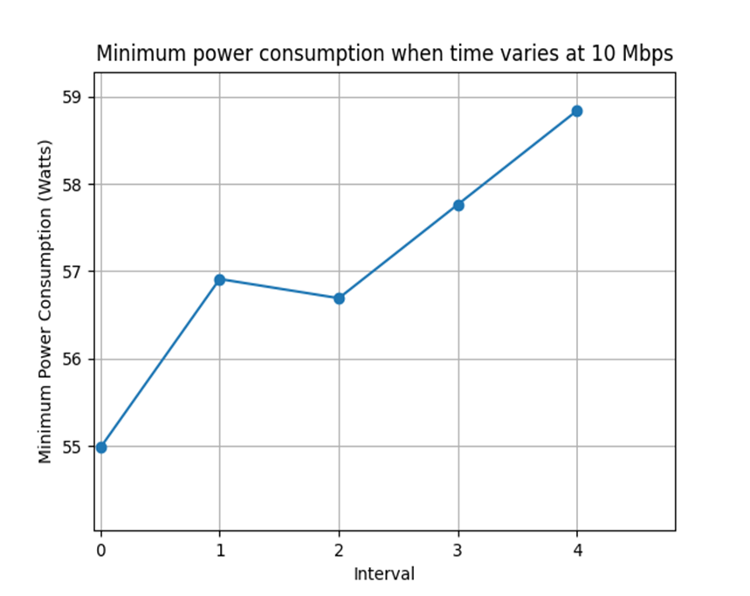

***Figure 4.2. Minimum total power consumption when time varies at 10 Mbps***

At the starting point, when UE demand = 10 Mbps, t = 0 s, we establish 55 W is the power consumption of the system based on (26). In the next 15s, the number of Watts increases and reaches approximately 57 W. Then, it drops slightly during the next interval. The process continues with a gradual increase in the amount of minimum power consumption in the last two intervals. After 60 s, the line finishes and reaches a peak at just under 59 W. From the graph, we collect 5 values of power from different intervals, namely 55 W, 57 W, 56.7 W, 57.7 W, 58.8 W to calculate the average total power consumption when UE demand is 10 Mbps.

Average Power = 57 (W)

It can be seen that although the speed requirements remain unchanged, energy is unstable due to the increase in circuit transmissions power when time rises. During this period, Threat to Interference (TTI) has not been optimized for the reason that there are hardly any predictions for the change of circuit transmissions power.

After the calculation of optimal average power consumption for 10 Mbps, we calculate values for other types of UE requirements, namely 20, 30, 40, 50 (Mbps) in a period of 60s. After simulating, the results are shown in Figure 4.3.

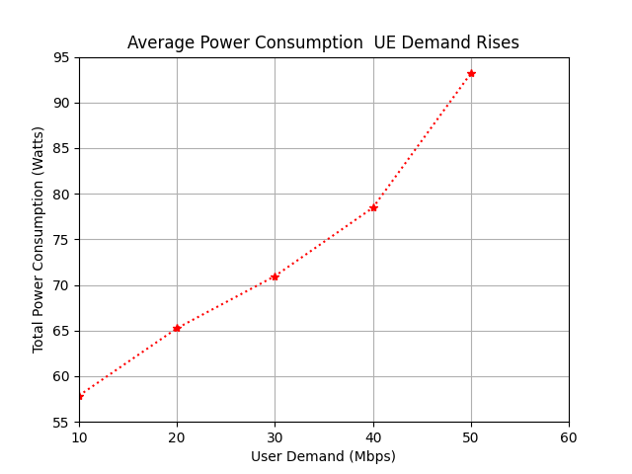

***Figure 4.3. Average total power consumption when UE demand changes***

The line graph indicates the average power required to satisfy different types of speed. Overall, it is seen that the system must produce more power to meet the need of users when their requirements rise. When UE demand increases to about 20 Mbps, the total power obtains about 65 W. At 30 Mbps, the whole system needs to supply over 70 W. Approximately 78 W is consumed to serve the demand for 40 Mbps. Lastly, for 50 Mbps, the amount of power consumption grows significantly as it obtains roughly 93 W. To conclude, after this period, we have the collection of optimal total power consumption of system for particular UE demand. The results are shown in the table below:

**Table 3. Simulation Results**

|  |  |
| --- | --- |
| **UE Demand (Mbps)** | **Optimal Power Consumption (W)** |
| 10 | 57 |
| 20 |  |
| 30 |  |
| 40 |  |
| 50 |  |

**CONCLUSION AND FUTURE ORIENTATION**

In this thesis, we investigated the power allocation problem over 5G UDN. Both EE and SE are considered in the network. Thus, the power optimization is considered to be a multi-objective problem to guarantee the QoS. In order to ensure the long-term performance of the UDN system, we have to calculate the optimal power consumption to save energy and improve SINR. In this scenario, the reinforcement learning method is used with the traditional Q-Learning method. Then, deep learning is applied to improve the performance of the system. The Deep Q Network (DQN) and its upgraded version, Dueling DQN were studied.

This thesis has mentioned the 5G UDN system model, calculates and collects the data of power consumption to fulfill QoS when UE demand changes in a period of time. It is shown from the simulation results that the system must produce more total power to satisfy UE demand for a long time. In this simulation, DQN algorithm is used to calculate the exact value of optimal power consumption for each user requirements scenario.

In future research, there are several recommendations:

* Research and evaluate the efficiency of another algorithm for power optimization, Dueling DQN.
* Find the solutions to stabilize the power consumption when time varies in a user demand scenario.
* Consider and research power allocation and multi-resource joint configuration in 5G UDN

**APPENDIX**

**Deep Q Network algorithms**

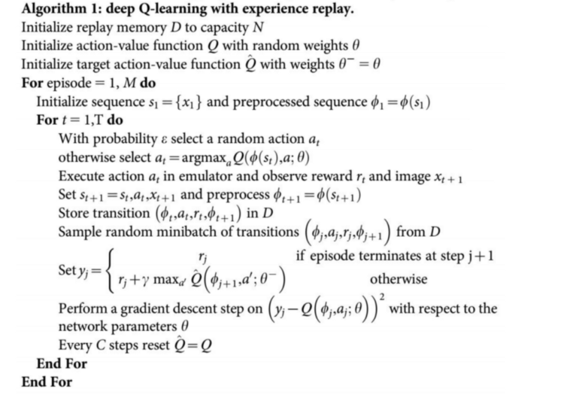

**REFERENCES**

**Vietnamese documents**

[1] Đinh Việt Anh. *Nâng cao hiệu quả sử dụng tài nguyên mạng mật độ siêu cao trong hệ thống 5G thông qua tối ưu hóa bản tin Paging*, Luận văn Thạc sĩ, Trường Đại học Công Nghệ, Đại học Quốc gia Hà Nội, 2018, tr.3-6.

[2] Đinh Việt Anh. *Nâng cao hiệu quả sử dụng tài nguyên mạng mật độ siêu cao trong hệ thống 5G thông qua tối ưu hóa bản tin Paging*, Luận văn Thạc sĩ, Trường Đại học Công Nghệ, Đại học Quốc gia Hà Nội, 2018, tr.7-9.

[3] Đinh Việt Anh. *Nâng cao hiệu quả sử dụng tài nguyên mạng mật độ siêu cao trong hệ thống 5G thông qua tối ưu hóa bản tin Paging*, Luận văn Thạc sĩ, Trường Đại học Công Nghệ, Đại học Quốc gia Hà Nội, 2018, tr.17-20.

[4] Đinh Việt Anh. *Nâng cao hiệu quả sử dụng tài nguyên mạng mật độ siêu cao trong hệ thống 5G thông qua tối ưu hóa bản tin Paging*, Luận văn Thạc sĩ, Trường Đại học Công Nghệ, Đại học Quốc gia Hà Nội, 2018, tr.23.

[5] Đinh Việt Anh. *Nâng cao hiệu quả sử dụng tài nguyên mạng mật độ siêu cao trong hệ thống 5G thông qua tối ưu hóa bản tin Paging*, Luận văn Thạc sĩ, Trường Đại học Công Nghệ, Đại học Quốc gia Hà Nội, 2018, tr.25.

[6] <https://cellphones.com.vn/sforum/giai-ngo-ve-5g-dung-de-cac-thuat-ngu-danh-lua-goi-la-5g-nhung-khong-han-da-la-5g-thuc-su?utm_source=sforum&utm_medium=thi-truong>

[7] <https://viblo.asia/p/gioi-thieu-ve-reinforcement-learning-rl-djeZ1GEY5Wz>

[8] <https://forum.machinelearningcoban.com/t/tutorial-implement-cac-thuat-toan-reinforcement-learning-ddpg-bai-1/3276>

[9] <https://viblo.asia/p/gioi-thieu-ve-hoc-tang-cuong-va-ung-dung-deep-q-learning-choi-game-cartpole-Az45bYy6lxY>

[10] <https://topdev.vn/blog/top-15-thu-vien-python-tot-nhat-cho-data-science-trong-2017/>

[11] <https://nttuan8.com/bai-3-neural-network/>

**Foreign documents**

[12] F. Barletta, F. Massimiani, F. Pierangeli, M. Spada, A. Marotta, F. Graziosi, *5G Networks. An Overall Perspective for the Innovation Management*, 2018 IEEE 4th International Forum on Research and Technology for Society and Industry (RTSI), 2018, Figure 1.

[13] <https://5g.systemsapproach.org/arch.html#mobile-core>

[14] Francois Rancy. *IMT for 2020 and Beyond*, Radiocommunication Bureau, International Telecommunication Union, 2019, Figure 6.3.

[15] <https://techblog.comsoc.org/2019/05/22/tech-mahindra-india-needs-to-begin-5g-spectrum-auction-now/>

[16] Félix Pablo CANO PAÍNO. *Implementation and evaluation of FD-MIMO beamforming schemes for highway scenarios*, Diploma Thesis, Vienna University of Technology, 2017, Figure 1.2, pp.3.

[17] M. Kamel, W. Hamouda, A. Youssef. *Ultra-Dense Networks: A Survey*, IEEE Communications Surveys & Tutorials, 2016, vol. 18, no. 4, pp.2522-2545.

[18] S. Wu, Z. Zeng, and H. Xia. *Load-Aware Energy Efficiency Optimization in Dense Small Cell Networks*, IEEE Communications letters, vol.21, 2017, pp. 366-369.

[19] Marnix Heskamp, Roel Schiphorst and Kees Slump. *Cognitive Radio Communications and Networks, Chapter 16. Public safety and cognitive radio, Section 16.3.6. System Spectral Efficiency*, 2010.

[20] C. C. Coskun, E. Ayanoglu. *Energy-spectral efficiency tradeoff for heterogeneous networks with QoS constraints*, Proc. IEEE International Conference on Communications (ICC), 2017, pp. 1-7.

[21] Zhiyong Liu, Xin Chen, Ying Chen, Zhuo Li. *Deep Reinforcement Learning Based Dynamic Resource Allocation in 5G Ultra-Dense Networks*, 2019 IEEE International Conference on Smart Internet of Things (SmartIoT), 2019, Fig 1.1, pp.169.

[22] Zhiyong Liu, Xin Chen, Ying Chen, Zhuo Li. *Deep Reinforcement Learning Based Dynamic Resource Allocation in 5G Ultra-Dense Networks*, 2019 IEEE International Conference on Smart Internet of Things (SmartIoT), 2019, pp.168-169.

[23] Zhiyong Liu, Xin Chen, Ying Chen, Zhuo Li. *Deep Reinforcement Learning Based Dynamic Resource Allocation in 5G Ultra-Dense Networks*, 2019 IEEE International Conference on Smart Internet of Things (SmartIoT), 2019, pp.170-172.

[24] <https://en.wikipedia.org/wiki/DBm>

[25] James Montantes. *What You Need to Know About Deep Reinforcement Learning*, towardsdatascience.com. 2020, The challenge of Model-Free RL.

[26] Chris Yoon. *Dueling Deep Q Networks*, towardsdatascience.com. 2019, Architecture

[27] Ziyu Wang, Tom Schaul, Matteo Hessel, Hado van Hasselt, Marc Lanctot, Nando de Freitas. *Dueling Network Architectures for Deep Reinforcement Learning*, 2016, Chapter 3.

[28] Ziyu Wang, Tom Schaul, Matteo Hessel, Hado van Hasselt, Marc Lanctot, Nando de Freitas. *Dueling Network Architectures for Deep Reinforcement Learning*, 2016, Figure 1.

[29] <https://www.electronics-notes.com/articles/basic_concepts/electronic-rf-noise/thermal-noise-calculations-calculator-formulas.php>

[30] <https://en.wikipedia.org/wiki/Fading>

[31] <https://datascience.stackexchange.com/questions/25317/what-are-the-pros-and-cons-of-keras-and-tflearn>

[32] <https://www.researchgate.net/figure/Bandwidth-scalability-in-3GPP-LTE-LTE-A_tbl1_272413342>

[33] <https://cvxopt.org/>

[34] <https://en.wikipedia.org/wiki/Neural_network>

[35] <https://wiki.pathmind.com/neural-network>

[36] <https://www.ibm.com/cloud/learn/machine-learning>